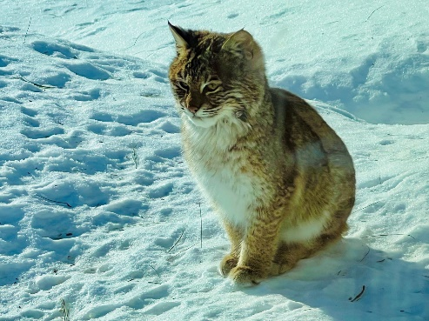
Making turkey stew on a cold winter day was never as eventful as it was on Saturday, February 4, 2023. Without the windchill factor, my thermometer read about -10 that morning. I had taken note that it was even too cold for the squirrels and birds to visit the feeders.
Around 2pm, as I was prepping to make the stew, I caught a glimpse out of the corner of my eye and saw what I thought could be a Maine Coon Cat on the deck. So, I stopped chopping veggies and took a closer look. The cat was now sitting up in the shoveled bird feeder path looking toward the deck and windows of the house. Not a house cat. As I went for my camera, my motion startled the cat and off it went. What a beautiful animal I had the privilege of gazing upon, and I thought, not all things were made to be photographed. Not long after, the bobcat was back and sitting tall and pretty on the slope of our snow-covered dock. My cell camera was close so I started to snap away and quickly made a few videos, knowing the visit would not last long. When I realized it was not going anywhere, back to the stew I went. I mean, who has time to sit and watch a bobcat in their dooryard all afternoon?
The bobcat stayed in the yard, explored under and around the docks, took several cat naps on the dock, on snow by the grill and on the deck. He caught a whiff of the red squirrels under the deck and crept and stalked, stopped, and listened for them. With our all-glass deck doors, the bobcat was literally a couple of feet away from me while on the deck. Around this time my first birds of the day, a cardinal couple swooped in on the bare lilac branches looking for a meal and the bobcat shifted, turned around and simply watched them. Around 5pm the golden, setting sun was the bobcat's cue to move on. This bobcat has been seen and photographed on North Shore Drive lounging on woodpiles, caught on a security camera walking with squirrel in its mouth, crossing the road, crossing my yard 2 days later and getting into trash in back of trucks in driveways. And yes, the stew was finally finished and topped off with dumplings!

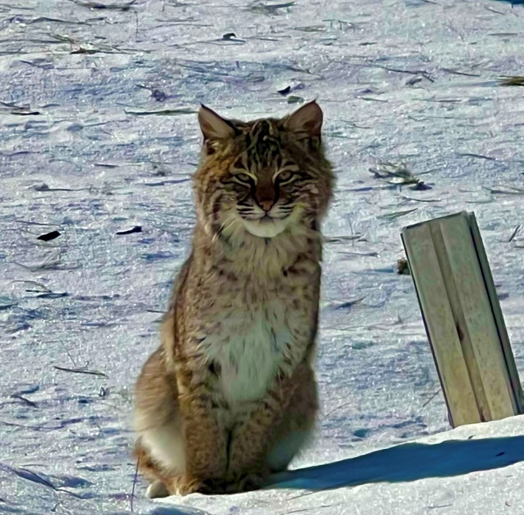
Jodie Mosher-Towle

