**2022 Class A Field Hockey State Champions**

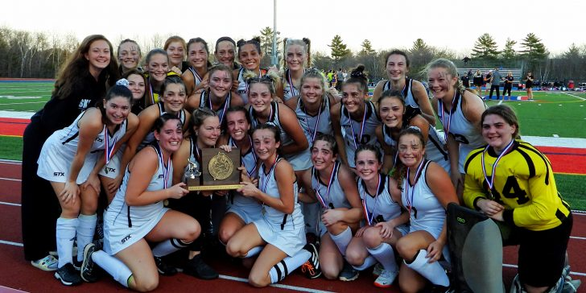

Norie Tibbetts, Sr. #21 Samantha Thebarge, Sr. #24 **Callaway LePage, Sr. #19-SMITHFIELD**

Riley Enright, Sr. #16 Kate Kelso, Sr. #2 Paige Gilbert, Sr. #10 Lanie Vanadestine, Sr. #4

Jackie Dodge, Sr. #7 Emmah Corson, Sr. #44 Nyah Gunst, Sr. #11 Masyn Atwood, Jr. #18

Laney LeBlanc, Jr. #6 Layla Conway, Jr. #14 Jayla Gentry, Jr. #22 Savanna Michaud, Jr. #12

Gemma Kennedy, Jr. #8 Kaylee Bruce, Jr. #3 Julia Fitzgerald, Jr. #23 Sydalia Savage, So. #1

Elli Quinn, So. #17 Lucia Siren, So. #9 Michela Provost, So. #15 Sophie Noyes, So. #28

**2022 Class A Varsity Girls Basketball  State Champions**

#23 Jayla Gentry-Norridgewock #2 Maddy Morris-Skowhegan #10 Aryana Lewis-Cornville

#22 Annabelle Morris-Skowhegan #34 Laney LeBlanc-Skowhegan #21 Kaysie Getchell-Cornville

#24 Julia Fitzgerald – Canaan #25 Carlie Jarvais-Skowhegan #12 Reese Danforth-Norridgewock

#3 Jaycie Christopher-Skowhegan #**31 Callaway LePage-Smithfield**

#20 Elle Donaghue-Skowhegan #15 Natalie Gilman-Canaan #**32 Allie Frey-Smithfield**

**2022 Class B Varsity Football State Champions**

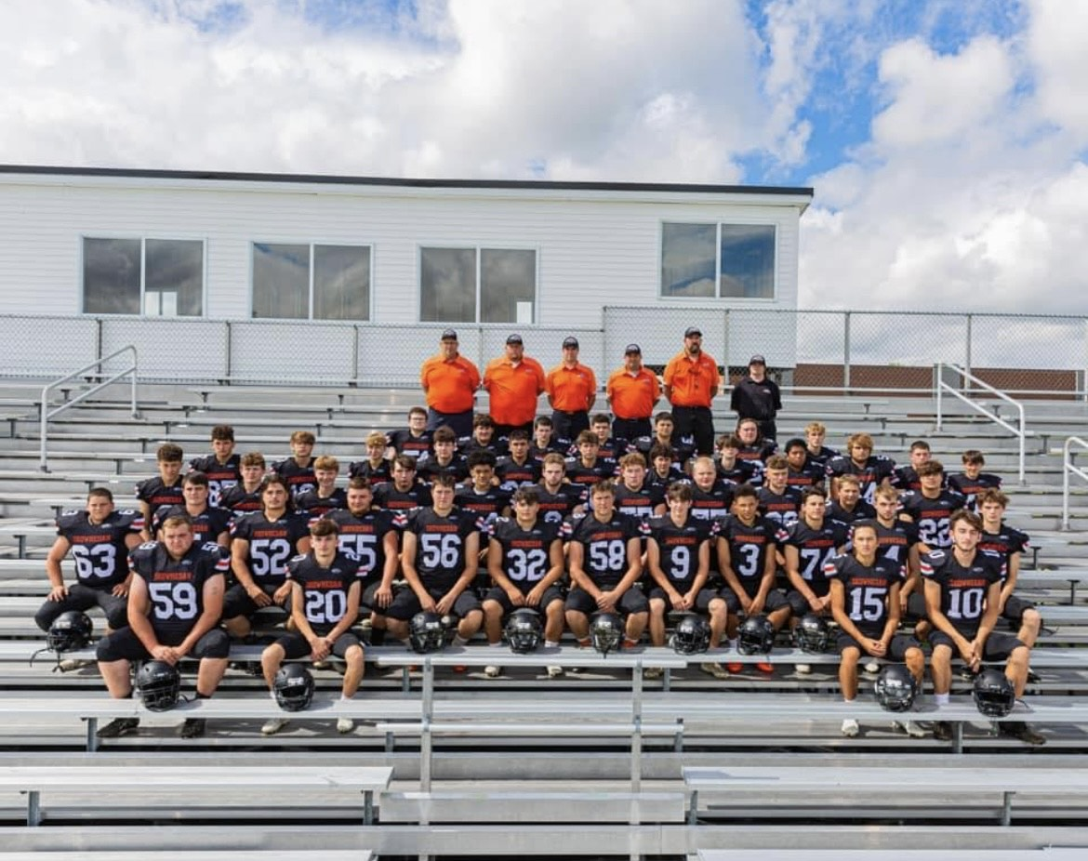

#5 Joseph Linkletter Sr. #6 Adam Fitzgerald Fr. #7 Wyatt Ellis Fr. #8 Brenden Dunlap Jr. #9 Tyler Annis Sr. #10 Adam Savage Sr. #11 Clarke Frederick So. #12 Preston Dishuk Fr. #13 Aydan Mulcahy Fr. #15 Ayden Brusa Sr. #20 Brandon Wyman Sr. #22 Bryson Howard So. #23 Cory Trial Fr. #**28 Trevor Austin WR, SS Fr.** #32 Hunter Mcewen Sr. #32 Andrew Wolman #33 Quintcey Mccray Sr. #51 Ben Linkletter Fr. #52 Caleb Pratt Sr. #53 Jj Howe Fr. #55 Kaden Salley Sr. #**56** **Collin LePage Sr. 58 Kyle LePage Sr.** 57 Owen Falardeau Jr. 59 Brayden Carr Sr. 60 Ben Steward So. 60 Trevor Tessier Sr. #62 Travis Coombs Fr. #63 Jeremiah Jencks Sr. #67 Tristan Turner Fr. #69 Craven Morehed Sr. #70 Sebastian Stewart Fr. #71 Bryce Jewell Jr. #73 Ghe Grip Fr. #74 Michael Welch Sr. #75 Brennan Boulette #75 Gavin Chillington Jr. #76 Jaimeson Shanoski Fr. #77 Brady Ducharme Fr. #79 Colton Koontz Sr. #79 Thomas Hebert Fr. #80 Terryn Shields Fr. #83 Miller Foss So. #84 Ekhayo Fairley Jr. #86 Troy Dudley Fr. #86 Will Spiller Sr. #87 Jason Aubin Fr. Darrin Gilman So. Mason Kelso Sr. Drake Tracy So. Tucker Morton So. Elijah Mellows So. Dalton Howard Jr. Mark Ouellette Jr. Isaiah Chestnutt Jr. Mason Swanson Jr. Hunter Gray So. Owyn Munn Sr.

**#56** **Collin LePage Sr.**

**#28 Trevor Austin Fr.**

**#58 Kyle LePage Sr**