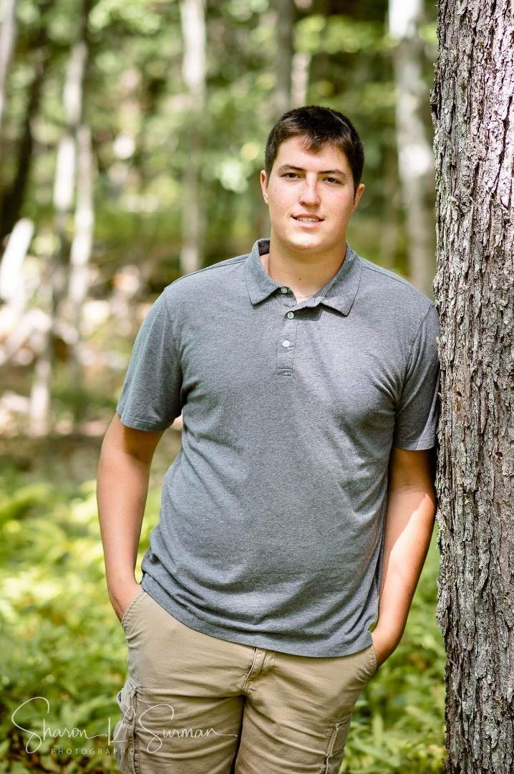

Colin LePage will be going to
Kennebec Valley Community College
for HVAC program

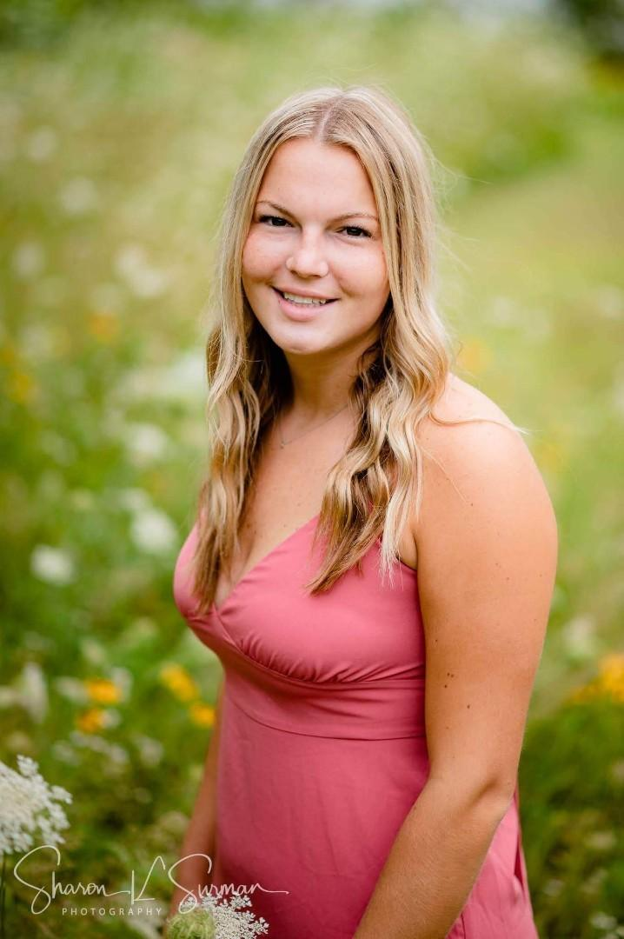

Callaway LePage will be going to
Husson University to study
Physical Therapy and play basketball

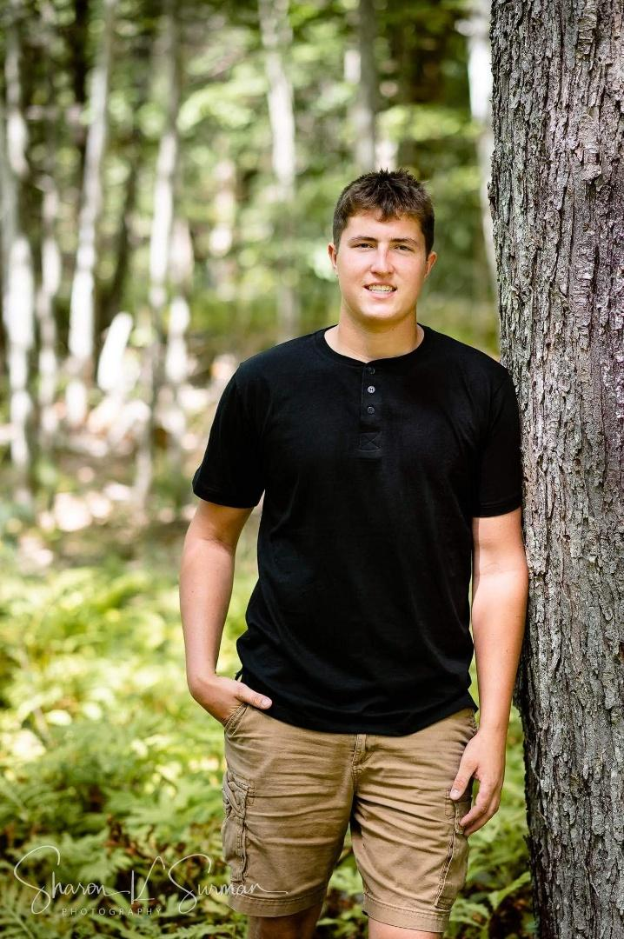

Kyle LePage will be going to
Kennebec Valley Community College
for the lineman program

