THANK YOU,
Cindy (Bulmer) Marceau!

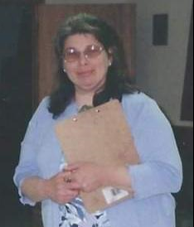

For 22 years Cindy has volunteered her time, wit, exuberant personality and writing skills by penning the cover story for each Smithfield town report. She carefully selected deserving individuals, couples, and families to be featured on the pages of our report, spending hours learning their stories and sharing them with each of us. This year Cindy “closed her notebook” and decided to focus on her many other volunteer ventures, many of which are close to home; she is the talent behind the beautiful photographs and posts for the Smithfield Historical Society’s social media pages and a (nearly) life-long member of The Fairview Grange. Additionally, Cindy is a caretaker at heart and has assisted many of our beloved residents in their golden years. Somehow, she still finds time to be a loving mother and daughter and have a job on top of all of this! What do you mean something has to go?!?

We will miss Cindy’s cover stories; however, we are grateful for her dedication over the last two decades. Enjoy “retirement”, Cindy! You leave big shoes to fill.

